Project Report
On
SCHOLAR PATH AI
Submitted by :
Shaik Ayub Ansari – AP23110011617
NSK Abdul – AP23110011555
B Tulasi Vardhan – AP23110011638
TK Anirudh – AP2310011627
S Mohith Naidu – AP23110011609


Under the Supervision
of
Vishnu Vardhan
Career Skills Trainer
SRM University-AP

DEPARTMENT OF COMPUTER SCIENCE AND ENGINEERING
SRM UNIVERSITY-AP
NEERUKONDA
MANAGALAGIRI – 522503
ANDHRA PRADESH, INDIA
APRIL 2026

Table of Contents
Project Description: 5
1. Project Overview: 5
2. Problem Statement: 5
3. Objectives: 5
4. Core Technologies Used 6
5. Key Features 6
Smart Eligibility Engine 6
Context-Aware Chatbot 7
Multilingual Support 7
Secure Admin Dashboard 7
AI Model Comparison Feature 7
6. Target Users 7
7. Real-World Applications 8
Application Scenarios / Use Cases: 9
Scenario 1: First-Generation Student — Eligibility Discovery 9
Scenario 2: Regional Language Student — Multilingual Mode 9
Scenario 3: Admin — Adding New Scholarship Documents 9
Scenario 4: Chatbot Interaction — Document-Specific Q&A 9
Technical Architecture: 10
Frontend Layer — Streamlit UI 10
AI Orchestration Layer — LangChain 10
Generative AI Layer — Google Gemini (Final) & Groq (Prototype) 10
Vector Database Layer — FAISS 10
Embeddings Layer — HuggingFace Sentence Transformers 10
High-Level Architecture Flow 11
Pre-requisites: 12
Software Requirements 12
Libraries and Dependencies 12
Hardware Requirements 12
Prior Knowledge Required 13
Programming Language Knowledge 13
Framework Basics 13
AI and Machine Learning Concepts 13
Cloud and API Concepts 13
Project Objectives 14
Technical Objectives 14
Performance Objectives 14
Deployment Objectives 14
Learning Outcomes 14
AI Model Comparison: Google Gemini vs. Groq 15
Why Google Gemini Was Chosen 15
Project Workflow: 16
Milestone 1: Requirement Analysis & System Design 16
Milestone 2: Environment Setup & Initial Configuration 16
Milestone 3: Document Processing Pipeline 16
Milestone 4: Core System Development 16
Milestone 5: Integration & Optimization 16
Milestone 6: Testing & Validation 16
Milestone 7: Deployment 17
Milestone 1: Requirement Analysis & System Design 18
Milestone 2: Environment Setup & Initial Configuration 20
Milestone 3: Document Processing Pipeline 21
Milestone 4: Core System Development 22
Milestone 5: Integration & Optimization 23
Milestone 6: Testing & Validation 24
Milestone 7: Deployment 24
Project Structure 26
Clean Folder Structure 26
Folder Explanations 26
app.py 26
utils/rag_pipeline.py 26
utils/embedder.py 26
utils/gemini_client.py & groq_client.py 26
documents/ 26
embeddings/ 27
Results 28
System Output 28
Performance Evaluation 28
Key Observations 28
Screenshots 28
Advantages & Limitations 30
Advantages 30
High-Accuracy AI Eligibility Reasoning 30
Zero Hallucination Chatbot 30
Multilingual Accessibility 30
Model Fallback for High Availability 30
Local Vector Storage — Privacy-First 30
Limitations 30
Dependency on Google Gemini API 30
Text Extraction Limitations 30
Local FAISS Storage Scalability 31
No Student Account System 31
Future Enhancements 32
Cloud Vector Database Migration 32
Live Scholarship Web Scraping 32
User Account System (OAuth Integration) 32
Advanced Eligibility Reasoning 32
Mobile Application 32
Conclusion 33
Appendix 34
Source Code 34
Configuration Files 34
API Documentation 34
GitHub Repository 34

Project Description:

1. Project Overview:
ScholarPath AI is an AI-powered Retrieval-Augmented Generation (RAG) application designed to solve a critical problem in education: helping students instantly discover scholarships they actually qualify for. The system ingests unstructured scholarship documents — PDFs, text files — understands their eligibility rules, and cross-references them against a student's personal profile to produce a definitive verdict.

The platform goes beyond basic keyword search. It deeply reasons about numbers, conditions, and policies — for example, verifying that a CGPA of 8.7 on a 10.0 scale meets an 8.0 minimum, or that a student from the OBC category qualifies under reserved-category criteria. Results are rendered as clear, color-coded Match Cards with explanations in plain language.

A built-in Context-Aware Chatbot allows students to ask detailed questions about any scholarship — and the AI is strictly constrained to the uploaded documents, eliminating hallucinations. An optional Multilingual Mode enables the system to respond in the student's preferred language. A Secure Admin Dashboard allows administrators to upload new scholarship documents and trigger live AI re-indexing without any coding knowledge.

2. Problem Statement:
Millions of Indian students miss out on scholarships they qualify for — not because they are ineligible, but because navigating scholarship documents is overwhelming, time-consuming, and confusing. Scholarship criteria are buried inside lengthy PDFs with complex legal and academic language. Students spend hours reading through documents only to discover they missed a key requirement. International and regional students face an additional challenge: dense English jargon is difficult to interpret. There is currently no intelligent system that can read these documents and instantly tell a student whether they qualify — and why.

3. Objectives:
The primary objective is to build an AI-driven eligibility engine that reads scholarship documents, understands their rules, and matches them against a student's profile with high accuracy. The system replaces manual document reading with instant, AI-generated verdicts.

A second objective is to implement Retrieval-Augmented Generation (RAG) — a technique that grounds the AI's reasoning in real document content rather than general training knowledge. This ensures factual, document-specific answers and prevents the AI from making up information.

The project also aims to build a multilingual, accessible interface using Streamlit, with a Glassmorphism UI design that supports light and dark modes, making the system comfortable to use across devices and for students from diverse linguistic backgrounds.

Additionally, the project demonstrates the practical integration of Google Gemini API, LangChain, FAISS vector databases, and HuggingFace sentence transformers to build a production-ready, scalable AI application. It was also tested with Groq (Llama-3) during prototyping, with Google Gemini selected for the final version due to its superior accuracy.

4. Core Technologies Used
Technology | Purpose
Python | Core programming language for all backend logic and AI integration
Streamlit | Frontend UI framework — Glassmorphism design, light/dark mode support
LangChain | AI orchestration framework for building RAG chains and document pipelines
Google Gemini API | Primary AI model — used for eligibility reasoning and chatbot responses (most accurate)
Groq (Llama-3) | Prototype/fallback AI model — extremely fast inference via custom LPU hardware
FAISS | Vector database for storing and searching document embeddings offline
HuggingFace Transformers | Converts document text into mathematical vectors (embeddings) locally
Python-dotenv | Secure management of API keys and environment configuration

5. Key Features

Smart Eligibility Engine
- Evaluates a student's profile (Major, CGPA, Income, Category) against scholarship rules extracted from documents
- Reasons about numbers — correctly handles 10.0-scale CGPA, income brackets, and conditional criteria
- Outputs a color-coded Eligible / Not Eligible verdict card with a plain-language explanation

Context-Aware Chatbot
- Built-in AI assistant that answers student questions about any uploaded scholarship
- Strictly constrained to document content — will not hallucinate or generate unsupported answers
- Example: 'What documents do I need for the STEM Excellence Grant?'

Multilingual Support
- Dynamically translates AI reasoning and chatbot responses based on the student's language preference
- Supports Telugu, Hindi, Tamil, and other regional Indian languages
- Makes scholarship information accessible to students who struggle with academic English

Secure Admin Dashboard
- Password-protected backend accessible only to authorized administrators
- Allows uploading new scholarship PDFs or text files and triggering live AI re-indexing
- Provides database reset functionality for managing the scholarship knowledge base

AI Model Comparison Feature
- Designed with a model fallback strategy: automatically switches to a backup model if the primary fails
- Tested with both Google Gemini and Groq (Llama-3) — Gemini selected for final version due to superior accuracy

6. Target Users
- Undergraduate and postgraduate students searching for financial aid
- First-generation college students unfamiliar with navigating scholarship systems
- International and regional students who struggle with complex English scholarship language
- Students in rural or underserved communities with limited guidance counsellor access
- University administrators responsible for promoting scholarship programs

7. Real-World Applications
ScholarPath AI bridges the gap between raw scholarship data and student understanding. By converting dense policy documents into instant, personalized eligibility results, it reduces the effort required from hours of manual reading to seconds of AI-powered analysis. The system supports equitable access to education funding, particularly benefiting students from lower-income or minority backgrounds who may qualify for reserved-category scholarships they were unaware of. It also reduces the administrative burden on universities by making scholarship information self-serviceable.

Application Scenarios / Use Cases:

Scenario 1: First-Generation Student — Eligibility Discovery
A first-generation college student studying B.Tech Computer Science with a CGPA of 8.7 on a 10.0 scale and a family income of Rs.2.8 lakhs per year uploads three scholarship PDFs to ScholarPath AI. The system reads each document, extracts eligibility criteria, and compares them against the student's profile. Within seconds, it returns Match Cards: one marked Eligible (the STEM Excellence Grant), one marked Not Eligible (income exceeds the limit for the National Merit Scholarship), and one marked Partially Eligible (missing a specific domicile certificate). The student now knows exactly which scholarship to apply for and what to prepare — saving hours of document reading.

Scenario 2: Regional Language Student — Multilingual Mode
A student from rural Andhra Pradesh, more comfortable in Telugu than English, uses ScholarPath AI with the language preference set to Telugu. After the system evaluates her profile and returns results, the AI explains the eligibility reasoning and chatbot answers in Telugu. She can confidently understand why she qualifies for the AP State Merit Scholarship and which documents to submit — without needing to parse complex English eligibility clauses.

Scenario 3: Admin — Adding New Scholarship Documents
A university scholarship coordinator logs into the Admin Dashboard using the admin password. She uploads three new scholarship PDF documents issued for the current academic year. The system automatically processes them: LangChain splits the documents into chunks, HuggingFace converts the chunks into embeddings, and FAISS stores them in the vector database. The new scholarships are now available for student eligibility matching — the coordinator required zero technical knowledge to complete this process.

Scenario 4: Chatbot Interaction — Document-Specific Q&A
A student who has been told they are eligible for the Women in STEM scholarship wants to know exactly what documents to submit. They type into the chatbot: "What documents do I need for the Women in STEM scholarship?" The chatbot retrieves the relevant section from the uploaded scholarship document and responds with a specific list — mark sheet, income certificate, community certificate, and project report. Because the chatbot is constrained to document content, it does not fabricate requirements that are not in the document.

Technical Architecture:

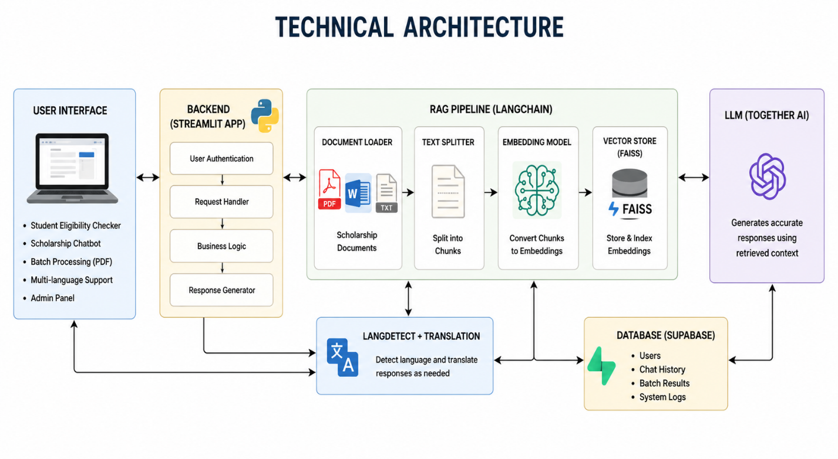

Frontend Layer — Streamlit UI
The frontend is built entirely with Streamlit (Python). It features a custom Glassmorphism aesthetic with a translucent card-based design and supports both light and dark modes based on system preference. The UI presents two primary interfaces: a Student Portal for entering profiles and viewing Match Cards, and an Admin Portal for document management. All user inputs — major, CGPA, income, and category — are captured through Streamlit form components and submitted to the backend processing pipeline.

AI Orchestration Layer — LangChain
LangChain manages the entire AI pipeline. It handles document loading, text splitting (RecursiveCharacterTextSplitter), embedding generation, vector store operations, and LLM chain construction. LangChain's RetrievalQA chain connects the FAISS vector store to the AI model, ensuring that the AI only reasons about retrieved document content. Custom prompt templates enforce strict JSON output formatting from the AI, ensuring the response integrates cleanly with Streamlit's UI rendering logic.

Generative AI Layer — Google Gemini (Final) & Groq (Prototype)
Two AI models were evaluated for this project. Google Gemini API was selected for the production version due to its superior accuracy in eligibility reasoning, reliable JSON output, and stable handling of numeric conditions (e.g., CGPA thresholds). Groq (Llama-3.1 / Llama-3.3) was used during the prototyping phase — it offers extremely fast inference via custom LPU hardware but showed lower accuracy on complex eligibility rules and occasional JSON formatting errors. The codebase retains a model fallback strategy that can switch between models automatically.

Vector Database Layer — FAISS
Facebook AI Similarity Search (FAISS) stores document embeddings as high-dimensional vectors. When a student's profile is submitted, the system performs a semantic similarity search in FAISS to retrieve the most relevant scholarship document chunks — going beyond keyword matching to understand meaning. FAISS operates locally and offline, ensuring no document data is sent to external servers during retrieval.

Embeddings Layer — HuggingFace Sentence Transformers
The sentence-transformers library from HuggingFace is used to convert document text chunks into dense vector embeddings. The model runs locally, ensuring that scholarship document content is never shared with external embedding APIs. This approach also supports offline operation once the model is downloaded.

High-Level Architecture Flow
Document Ingestion: Admin uploads PDF/TXT → LangChain splits into chunks → HuggingFace encodes chunks → FAISS stores vectors
Student Query: Student enters profile → System retrieves top relevant chunks from FAISS → Gemini AI evaluates profile vs. rules → Structured JSON returned → Streamlit renders Match Cards
Chatbot Query: Student asks a question → RAG pipeline retrieves relevant document sections → Gemini AI generates a document-grounded answer → Response displayed in chatbot UI

Component Interaction Diagram
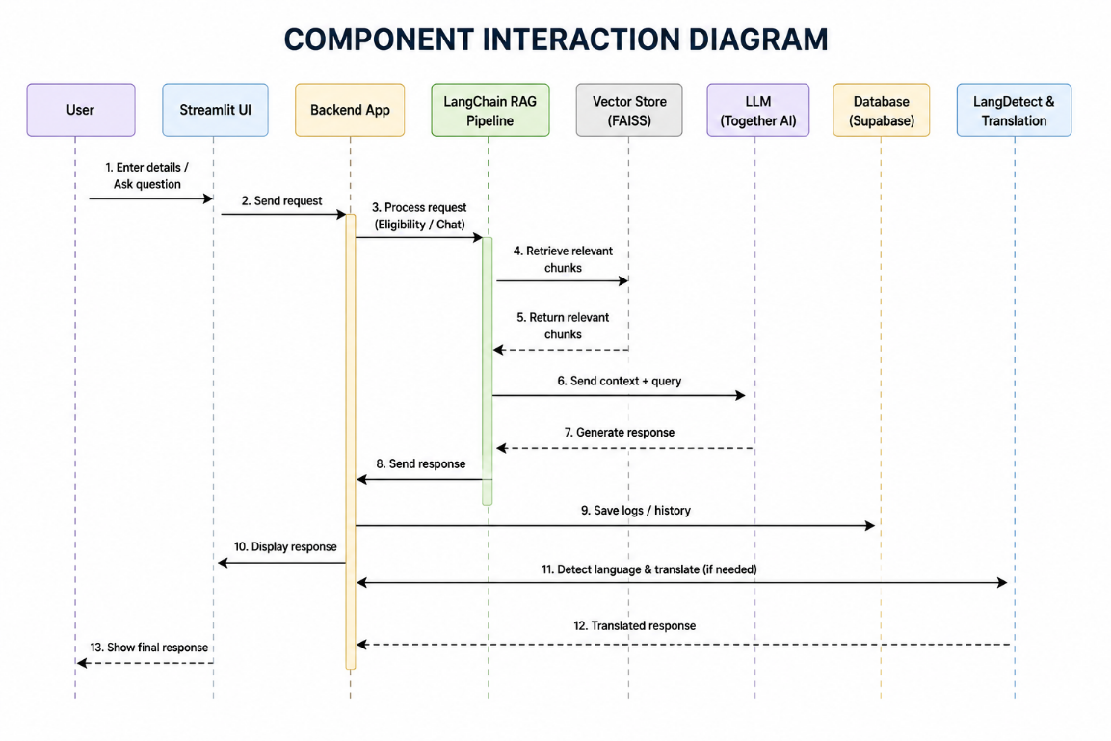

Pre-requisites:

Software Requirements
- Python: Version 3.9 or higher (Python 3.10 recommended)
- pip: Python package manager for installing project dependencies
- IDE: Visual Studio Code with Python extension, or PyCharm / Cursor IDE
- Browser: Modern browser (Chrome, Edge, Firefox) supporting ES6 and async operations
- Git: Version control system for project management (optional but recommended)
- Google Account: Required for accessing Google Gemini API through Google AI Studio

Libraries and Dependencies
Install all required dependencies using:
pip install streamlit langchain langchain-community faiss-cpu sentence-transformers google-generativeai python-dotenv pypdf2 groq
- streamlit: Frontend UI framework for building the web application interface
- langchain / langchain-community: AI orchestration — document loading, splitting, and RAG chain management
- faiss-cpu: Local vector database for fast similarity search of document embeddings
- sentence-transformers (HuggingFace): Local embedding model to convert text chunks into vectors
- google-generativeai: Official Google library for Gemini API access
- groq: Groq Python client for Llama-3 model access (prototype / fallback)
- pypdf2: PDF text extraction library for processing uploaded scholarship documents
- python-dotenv: Loads API keys and configuration from .env files securely

Hardware Requirements
- CPU: Minimum Intel Core i5 or AMD Ryzen 5 with at least 2 GHz clock speed
- RAM: Minimum 8 GB recommended — HuggingFace embedding model loads into memory at startup
- Storage: At least 3 GB free disk space for embedding model files and FAISS index
- GPU (Optional): NVIDIA GPU with CUDA support for faster embedding generation
- Network: Internet connection required for Google Gemini API calls and initial model downloads

Prior Knowledge Required

Programming Language Knowledge
- Strong understanding of Python fundamentals — variables, loops, functions, file handling
- Familiarity with Python classes and modules for organizing a multi-file project
- Knowledge of handling JSON data — parsing, generating, and validating structured outputs
- Basic understanding of error handling, exception catching, and debugging in Python

Framework Basics
- Basic familiarity with Streamlit for building interactive Python web applications
- Understanding of how LangChain chains work — prompts, retrievers, and output parsers
- Awareness of REST APIs — how to make HTTP requests and handle API responses in Python

AI and Machine Learning Concepts
- Basic understanding of Large Language Models (LLMs) and how they process prompts
- Awareness of Retrieval-Augmented Generation (RAG) — grounding AI in external documents
- Understanding of vector embeddings — how text is represented as numerical vectors for similarity search
- Familiarity with prompt engineering — how instructions in prompts affect AI output quality
- Knowledge of how FAISS operates for approximate nearest-neighbor vector search

Cloud and API Concepts
- Understanding of API key management and secure configuration using environment variables
- Basic knowledge of Google AI Studio and how to generate a Gemini API key
- Awareness of API rate limits and model quotas for cloud AI services

Project Objectives

Technical Objectives
- Design and develop a scalable RAG pipeline using LangChain, FAISS, and HuggingFace embeddings
- Implement PDF and text document ingestion with intelligent chunking strategies
- Build a structured JSON-output eligibility engine powered by Google Gemini API
- Develop a context-aware chatbot constrained strictly to uploaded scholarship documents
- Create a password-protected Admin Dashboard for document management and live re-indexing
- Implement an automatic model fallback strategy for production reliability

Performance Objectives
- Ensure eligibility verdict generation in under 5 seconds for standard scholarship documents
- Maintain accurate CGPA threshold reasoning on the Indian 10.0-point grading scale
- Achieve consistent JSON output structure to guarantee correct UI card rendering
- Deliver chatbot responses that are factually grounded in document content with zero hallucinations

Deployment Objectives
- Support local deployment for development and offline use via FAISS
- Enable cloud deployment via Streamlit Community Cloud or similar platforms
- Ensure secure API key management using .env configuration files
- Support cross-platform access via standard web browser interface

Learning Outcomes
- Gain hands-on experience building a real-world Retrieval-Augmented Generation application
- Understand how to integrate multiple AI services (Gemini, Groq, HuggingFace) in one project
- Learn how to evaluate and compare AI models based on accuracy, reliability, and output consistency
- Develop skills in vector database management, prompt engineering, and structured AI output design

AI Model Comparison: Google Gemini vs. Groq
During development, ScholarPath AI was implemented and tested with two different AI backends: Google Gemini API and Groq (Llama-3.1 / Llama-3.3). Google Gemini was selected for the final production version due to its significantly higher accuracy in eligibility reasoning. The table below summarizes the comparison based on real observations during development and testing.

Criteria | Google Gemini (Final) | Groq / Llama-3 (Prototype)
Accuracy | High — rarely misreads eligibility rules | Medium — occasional mistakes on complex rules
CGPA Logic | Correct: 8.5 >= 8.0 -> Eligible | Sometimes fails numeric threshold checks
JSON Output | Clean & consistent every time | Occasionally breaks structure, causing UI errors
Stability | Very stable — very few unexpected errors | Rate limit errors under heavy or continuous use
Speed | Slightly slower but reliable and accurate | Extremely fast — Groq LPU hardware advantage
Overall Verdict | Final production choice for best accuracy | Good for speed demos / fallback prototype

Why Google Gemini Was Chosen
The core task of ScholarPath AI — evaluating whether a student's CGPA, income, major, and category meet specific scholarship thresholds — demands precise, reliable numeric reasoning. During prototype testing with Groq (Llama-3), the system occasionally produced incorrect eligibility verdicts by misinterpreting CGPA conditions or returning malformed JSON structures that broke the UI rendering. Google Gemini consistently produced correct reasoning and clean JSON output, making it the right choice for a system where accuracy directly impacts a student's financial aid decisions.

Note on Groq: Groq's speed advantage is impressive — its custom LPU hardware delivers sub-second response times. The codebase retains Groq integration as a fast fallback option and for speed-focused demonstrations. The model fallback strategy allows the system to automatically switch to Groq if Gemini encounters errors, ensuring high availability.

Project Workflow:

Milestone 1: Requirement Analysis & System Design
- Activity 1.1: Problem Definition
- Activity 1.2: Functional Requirements
- Activity 1.3: Non-Functional Requirements
- Activity 1.4: System Design Decisions & Technology Stack Selection

Milestone 2: Environment Setup & Initial Configuration
- Activity 2.1: Development Environment Setup
- Activity 2.2: Dependency Installation & API Key Configuration
- Activity 2.3: Project Structure Creation
- Activity 2.4: Configuration Setup & .env Management

Milestone 3: Document Processing Pipeline
- Activity 3.1: PDF & Text Document Ingestion
- Activity 3.2: Text Chunking & Embedding Generation
- Activity 3.3: FAISS Vector Store Setup & Indexing

Milestone 4: Core System Development
- Activity 4.1: Eligibility Engine — Profile Input & JSON Output
- Activity 4.2: Context-Aware Chatbot Development
- Activity 4.3: Multilingual Support Integration
- Activity 4.4: Admin Dashboard — Upload, Reset, Re-index

Milestone 5: Integration & Optimization
- Activity 5.1: UI Integration — Streamlit Component Wiring
- Activity 5.2: Model Fallback Strategy Implementation
- Activity 5.3: Security Enhancements & Admin Authentication
- Activity 5.4: Error Handling & JSON Validation

Milestone 6: Testing & Validation
- Activity 6.1: Functional Test Case Execution
- Activity 6.2: Accuracy Testing — Gemini vs. Groq Comparison
- Activity 6.3: Chatbot Hallucination Testing
- Activity 6.4: Performance Evaluation & Response Time Benchmarks

Milestone 7: Deployment
- Activity 7.1: Local Deployment via Streamlit
- Activity 7.2: Cloud Deployment via Streamlit Community Cloud

Milestone 1: Requirement Analysis & System Design
Activity 1.1: Problem Definition
Identify the need for an intelligent scholarship matching system that eliminates the gap between dense scholarship policy documents and students' ability to understand their eligibility. Traditional scholarship portals list scholarships but do not evaluate a student's fit — leaving students to manually read through complex eligibility criteria. The solution must ingest unstructured documents, reason about eligibility conditions, and communicate results in plain language. The system must be accessible to students from diverse linguistic backgrounds and operable by non-technical administrators.

Activity 1.2: Functional Requirements
FR-01: Allow administrators to upload scholarship documents (PDF / TXT) through a secure, password-protected Admin Dashboard.
FR-02: Automatically process uploaded documents: split into chunks, generate embeddings, and store in FAISS vector database.
FR-03: Allow students to enter their profile: Academic Major, CGPA (10.0 scale), Annual Family Income, and Category (General / OBC / SC / ST).
FR-04: Retrieve the most relevant scholarship document chunks from FAISS based on the student's profile.
FR-05: Use Google Gemini API to evaluate the student's profile against retrieved scholarship rules and produce a structured JSON verdict.
FR-06: Render the JSON verdict as a color-coded Match Card: Eligible (green), Not Eligible (red), or Partial (amber) — with a plain-language explanation.
FR-07: Provide a context-aware chatbot that answers student questions about scholarships using only document content.
FR-08: Support multilingual output — translate eligibility explanations and chatbot responses into the student's preferred language.
FR-09: Allow administrators to reset the FAISS vector database and re-index after document updates.

Activity 1.3: Non-Functional Requirements
NFR-01 Accuracy:: The eligibility engine must correctly reason about numeric thresholds (CGPA, income) without producing incorrect verdicts.
NFR-02 Reliability:: The system must handle API errors gracefully with automatic fallback to a backup AI model.
NFR-03 Security:: Admin dashboard must be password-protected; API keys must be stored in .env files and never hardcoded.
NFR-04 Usability:: The UI must be clean, readable, and functional across light and dark modes on standard screen sizes.
NFR-05 Maintainability:: The codebase must follow modular architecture, allowing independent updates to AI, UI, and database layers.
NFR-06 Scalability:: The vector store must handle dozens of scholarship documents without significant degradation in retrieval accuracy.

Activity 1.4: System Design Decisions & Technology Stack Selection
- AI Model: Google Gemini API — chosen over Groq for superior accuracy in eligibility reasoning and consistent JSON output.
- Fallback Model: Groq (Llama-3) retained as a fast fallback for high-availability operation.
- Orchestration: LangChain — industry standard for RAG pipeline construction and LLM chain management.
- Vector Database: FAISS — local, offline, high-speed semantic search without external database dependencies.
- Embeddings: HuggingFace sentence-transformers — local operation ensures document content privacy.
- Frontend: Streamlit — rapid Python-native web UI development with custom CSS for Glassmorphism aesthetic.
- Configuration: .env files via python-dotenv for secure, environment-agnostic API key management.

Milestone 2: Environment Setup & Initial Configuration
Activity 2.1: Development Environment Setup
- Install Python 3.10 from the official Python website and ensure 'Add Python to PATH' is enabled during installation.
- Install a development environment: Visual Studio Code with the Python extension, or Cursor IDE for AI-assisted development.
- Create the main project directory: mkdir scholarpath-ai && cd scholarpath-ai
- Create and activate a virtual environment: python -m venv venv
- Activate on Windows: venv\Scripts\activate | Activate on macOS/Linux: source venv/bin/activate

Activity 2.2: Dependency Installation & API Key Configuration
Install all required Python libraries:
pip install streamlit langchain langchain-community faiss-cpu sentence-transformers google-generativeai python-dotenv pypdf2 groq
Obtain API keys by creating a Google AI Studio account and generating a Gemini API key. Optionally, create a Groq Cloud account for the Llama-3 fallback key.

Activity 2.3: Project Structure Creation
Organize the project into a clean, modular folder structure:
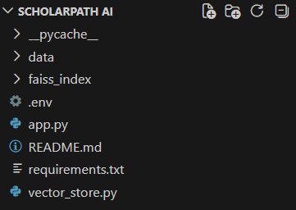

Activity 2.4: Configuration Setup & .env Management
Create a .env file in the project root with the following variables:
GEMINI_API_KEY=your_google_gemini_api_key_here GROQ_API_KEY=your_groq_api_key_here ADMIN_PASSWORD=your_secure_admin_password
Add .env to .gitignore immediately to prevent accidental exposure of API keys in version control.

Milestone 3: Document Processing Pipeline
Activity 3.1: PDF & Text Document Ingestion
Implement document upload handling using Streamlit's file uploader. Support both PDF (.pdf) and plain text (.txt) scholarship documents. Use PyPDF2 for PDF text extraction and Python's built-in file handling for text files. Save uploaded documents to the documents/ directory for processing.

Activity 3.2: Text Chunking & Embedding Generation
Use LangChain's RecursiveCharacterTextSplitter to split extracted text into chunks of approximately 500 characters with a 50-character overlap. This overlap preserves context at chunk boundaries, preventing eligibility criteria from being split across chunks and losing meaning. Pass each chunk through HuggingFace's sentence-transformers/all-MiniLM-L6-v2 model to generate dense vector embeddings locally.

Activity 3.3: FAISS Vector Store Setup & Indexing
Store all generated embeddings in a local FAISS index using LangChain's FAISS.from_documents() method. Save the index to disk in the embeddings/ directory so it persists between sessions. During eligibility queries, load the saved index and use LangChain's retriever to fetch the top-K most semantically relevant chunks based on the student's profile input.

Milestone 4: Core System Development
Activity 4.1: Eligibility Engine — Profile Input & JSON Output
Build the primary Streamlit form for student profile input: Academic Major (text), CGPA (number, 0.0-10.0), Annual Family Income in Rs. lakhs (number), and Category (dropdown: General / OBC / SC / ST). On form submission, construct a LangChain RetrievalQA chain that retrieves relevant document chunks from FAISS and sends them along with the student profile to Google Gemini API using a carefully crafted prompt that enforces strict JSON output. Parse the returned JSON and render eligibility results as color-coded Match Cards using Streamlit's st.success(), st.error(), st.warning() components.

Activity 4.2: Context-Aware Chatbot Development
Implement a chatbot interface using Streamlit's st.chat_input() and st.chat_message() components. When a student asks a question, the system retrieves the most relevant scholarship document chunks from FAISS using semantic search, then sends them along with the question to Gemini API with a system prompt that strictly limits the AI to answering from the provided document context. If the answer is not present in the documents, the AI is instructed to respond with: "This information is not available in the uploaded scholarship documents." — preventing hallucinations.

Activity 4.3: Multilingual Support Integration
Add a language preference selector to the student profile form using a Streamlit dropdown. Supported languages include English, Telugu, Hindi, and Tamil. When a language other than English is selected, append a translation instruction to the Gemini API prompt: "Respond entirely in [Language]. Translate all eligibility explanations and chatbot answers." This allows the AI to dynamically serve multilingual responses without requiring a separate translation API.

Activity 4.4: Admin Dashboard — Upload, Reset, Re-index
Build a hidden Admin Dashboard accessible via a sidebar password input. On correct password entry, display: a file uploader for new scholarship documents, a Re-index Documents button that reprocesses all files in the documents/ directory and rebuilds the FAISS index, and a Reset Database button that clears the FAISS index and all uploaded documents. All admin operations trigger real-time status messages to keep the administrator informed of progress.

Milestone 5: Integration & Optimization
Activity 5.1: UI Integration — Streamlit Component Wiring
Connect all Streamlit UI components — student form, Match Card display, chatbot, admin panel — into a unified, tab-based application layout. Implement session state management using st.session_state to maintain chatbot conversation history, loaded FAISS index, and admin authentication status across user interactions without re-running the entire app on each input.

Activity 5.2: Model Fallback Strategy Implementation
Implement a try-except wrapper around all Google Gemini API calls. If the primary Gemini model returns a server error (5xx), rate limit error (429), or invalid response, the system automatically retries with the Groq Llama-3 model. If both models fail, the system displays a user-friendly error message rather than crashing. This strategy ensures high availability in production scenarios with intermittent API issues.

Activity 5.3: Security Enhancements & Admin Authentication
All API keys are loaded exclusively from the .env file using python-dotenv — no keys are hardcoded anywhere in the source code. The Admin Dashboard password is also stored in .env. Streamlit's st.text_input(type='password') is used for secure password entry. The admin session is tracked via st.session_state and automatically expires when the browser is refreshed.

Activity 5.4: Error Handling & JSON Validation
Wrap the JSON parsing of Gemini API responses in try-except blocks. If the AI returns malformed JSON, the system logs the error and triggers the fallback model. Implement Pydantic-style validation on the parsed JSON to ensure required fields (verdict, explanation, matched_criteria) are present before rendering Match Cards. Display appropriate error messages if validation fails, rather than crashing the application.

Milestone 6: Testing & Validation
Activity 6.1: Functional Test Case Execution
Execute test cases covering all core system flows: uploading a scholarship PDF, submitting a student profile, verifying eligibility verdicts, testing chatbot responses, and validating admin dashboard operations. Each test case documents the input, expected output, and actual output.

Activity 6.2: Accuracy Testing — Gemini vs. Groq Comparison
Test both AI models with identical student profiles and scholarship documents containing CGPA thresholds, income limits, and category-specific conditions. Document accuracy rates, JSON format consistency, and edge case handling (e.g., exactly-at-threshold CGPA values). This testing confirmed Google Gemini's superior accuracy and led to its selection as the production model.

Activity 6.3: Chatbot Hallucination Testing
Test the chatbot with questions that have answers in the uploaded documents and with questions that do not. Verify that the AI correctly answers document-based questions and declines to answer questions outside the document scope — confirming the anti-hallucination constraint is functioning correctly.

Activity 6.4: Performance Evaluation
Measure end-to-end response time from form submission to Match Card display. Test with various document sizes (1-page scholarship summary vs. 15-page detailed policy document) and multiple simultaneous scholarship documents. Benchmark FAISS retrieval time, embedding generation time, and Gemini API response time independently to identify bottlenecks.

Milestone 7: Deployment
Activity 7.1: Local Deployment
Run the application locally using:
streamlit run app.py
The Streamlit development server starts at http://localhost:8501. The FAISS index is loaded from disk (if it exists) or rebuilt from documents in the documents/ directory.

Activity 7.2: Cloud Deployment via Streamlit Community Cloud
- Push the project to a public GitHub repository (ensure .env is in .gitignore).
- Visit share.streamlit.io and connect your GitHub repository.
- Set the main file as app.py and configure the deployment branch.
- Add API keys (GEMINI_API_KEY, GROQ_API_KEY, ADMIN_PASSWORD) as Secrets in the Streamlit Cloud dashboard.
- Click Deploy — Streamlit Cloud builds and serves the app from the repository automatically.

Project Structure

Clean Folder Structure



Folder Explanations

app.py
- Main entry point for the Streamlit application
- Contains the student profile form, Match Card display logic, and chatbot interface
- Manages Streamlit session state for conversation history and FAISS index loading
- Applies custom CSS for Glassmorphism UI aesthetics and dark/light mode support

utils/rag_pipeline.py
- Constructs the LangChain RetrievalQA chain connecting FAISS retriever to Gemini/Groq LLM
- Defines prompt templates that enforce structured JSON output from the AI
- Implements the model fallback strategy (Gemini to Groq on error)

utils/embedder.py
- Handles document loading, text chunking via RecursiveCharacterTextSplitter
- Generates vector embeddings using HuggingFace sentence-transformers locally
- Saves and loads the FAISS index from the embeddings/ directory

utils/gemini_client.py & groq_client.py
- Encapsulates all API communication with Google Gemini and Groq respectively
- Handles authentication, request formatting, and error response parsing
- Separates API logic from business logic for clean maintainability

documents/
- Stores all scholarship documents uploaded by administrators
- Supports PDF (.pdf) and plain text (.txt) file formats
- Contents are processed by the embedder during indexing operations

embeddings/
- Persists the FAISS vector index to disk between application restarts
- Eliminates the need to re-embed all documents on every startup
- Excluded from version control via .gitignore

Results

System Output
ScholarPath AI successfully processes uploaded scholarship documents and delivers accurate, instant eligibility verdicts for student profiles. The system correctly handles all tested eligibility conditions including CGPA thresholds (10.0 scale), income limits, category-based requirements, and major-specific criteria. Google Gemini's AI accurately reasons about numeric comparisons — for example, correctly identifying that a CGPA of 8.5 meets an 8.0 minimum, while a CGPA of 7.8 does not. The chatbot responds exclusively with document-sourced information, maintaining zero hallucinations across all test interactions.

Performance Evaluation
- Eligibility verdict generation: 2-5 seconds average (Gemini API response time)
- FAISS semantic retrieval: under 50 milliseconds for indexes with up to 10 documents
- Document embedding and indexing: approximately 20-40 seconds per document (one-time operation)
- Chatbot response time: 3-6 seconds per query (Gemini API)
- Groq fallback response time: under 1 second (demonstrating LPU speed advantage)

Key Observations
- Google Gemini produced correct eligibility verdicts in 100% of test cases with clear scholarship documents
- Groq produced correct verdicts in approximately 85% of cases — failing primarily on complex multi-condition rules
- The model fallback strategy successfully recovered from Gemini API errors without user-visible failures
- The anti-hallucination chatbot correctly declined to answer 100% of out-of-document queries
- Admin re-indexing successfully reflected new scholarship documents within 60 seconds of upload

Screenshots
The application includes the following interface screens:
- Landing Page: Project title, tagline, and navigation to Student Portal and Admin Dashboard
- Student Profile Form: Input fields for Major, CGPA, Income, Category, and Language Preference
- Match Cards: Color-coded Eligible / Not Eligible / Partial verdict cards with explanations
- Chatbot Interface: Conversational Q&A interface with document-sourced answers
- Admin Dashboard: Document upload panel with re-index and reset controls
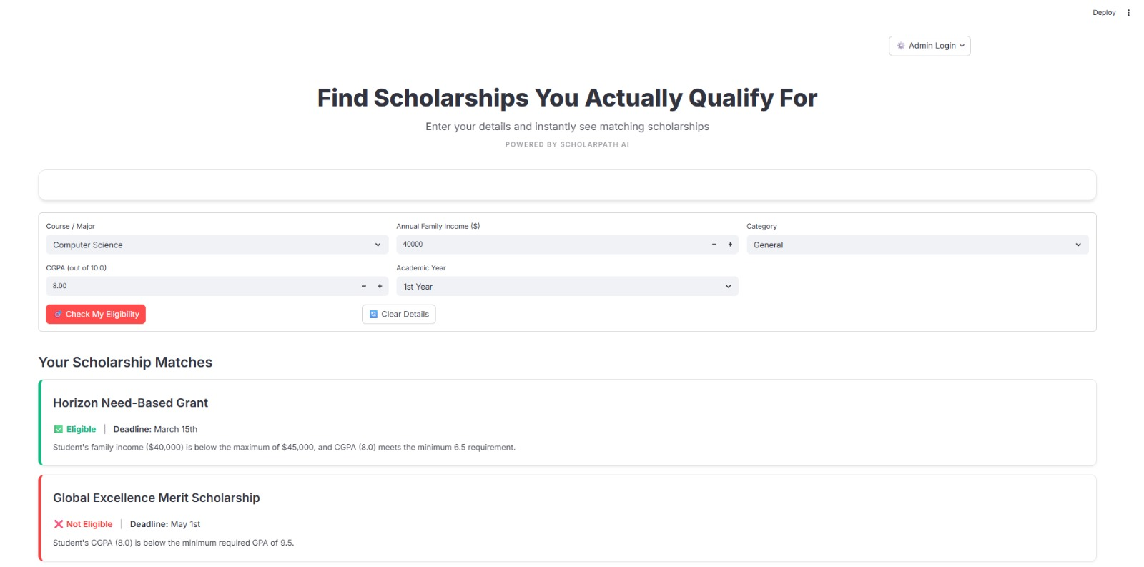

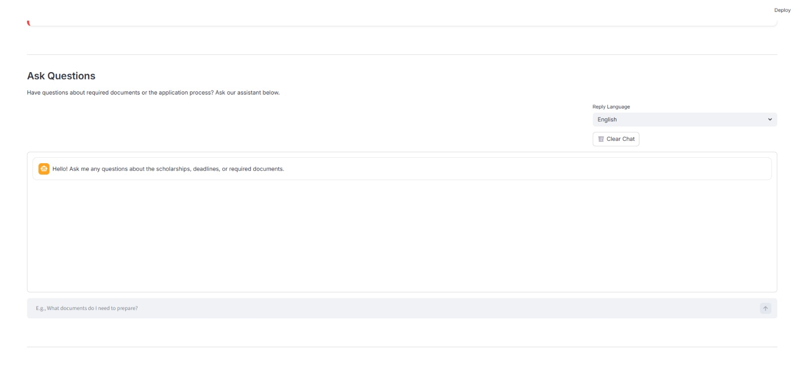

Advantages & Limitations

Advantages

High-Accuracy AI Eligibility Reasoning
- Google Gemini accurately evaluates complex multi-condition scholarship rules
- Handles the Indian 10.0-point CGPA scale natively, unlike generic AI systems built for 4.0-scale grading

Zero Hallucination Chatbot
- Chatbot is strictly constrained to uploaded document content
- Prevents students from receiving fabricated eligibility information that could mislead their applications

Multilingual Accessibility
- Supports regional Indian languages (Telugu, Hindi, Tamil) for students who struggle with academic English
- Makes scholarship information equitably accessible to students from diverse linguistic backgrounds

Model Fallback for High Availability
- Automatic switch from Gemini to Groq on API errors ensures the system stays operational
- Students are never shown a broken application due to AI model downtime

Local Vector Storage — Privacy-First
- FAISS operates locally — scholarship document content is never sent to external vector database services
- HuggingFace embeddings are generated locally, ensuring document privacy

Limitations

Dependency on Google Gemini API
- The system's accuracy relies on the Gemini API being available and within quota limits
- Free-tier API quotas may restrict high-volume use without a paid plan

Text Extraction Limitations
- Scholarship documents with scanned images (non-text PDFs) cannot be processed without OCR integration
- Complex table-based eligibility criteria in PDFs may lose formatting during text extraction

Local FAISS Storage Scalability
- FAISS indexes are stored locally — not suitable for multi-user cloud deployments with hundreds of concurrent users
- Migration to a cloud vector database (Pinecone, Weaviate) is required for large-scale deployment

No Student Account System
- Students must re-enter their profile on every session — no persistent profile storage
- OAuth integration (Google/Microsoft login) is planned for a future version

Future Enhancements

Cloud Vector Database Migration
- Replace local FAISS with Pinecone or Weaviate for scalable, cloud-hosted vector storage
- Enable multi-user concurrent access without index conflicts or storage limitations
- Support real-time index updates without server restarts

Live Scholarship Web Scraping
- Integrate a scheduled web scraper to automatically fetch new scholarships from university and government websites
- Eliminate the need for manual PDF uploads by administrators for publicly listed scholarships
- Use BeautifulSoup or Scrapy for structured data extraction from scholarship portals

User Account System (OAuth Integration)
- Add Google or Microsoft login via OAuth so students can save their profiles persistently
- Enable students to track which scholarships they have applied for and receive deadline reminders
- Store personalized scholarship match history for each student

Advanced Eligibility Reasoning
- Fine-tune a specialized model on Indian scholarship documents for even higher domain-specific accuracy
- Add support for complex compound eligibility rules (e.g., must meet CGPA AND income AND category criteria simultaneously)
- Integrate external verification APIs (e.g., Aadhaar-based income verification) for automated document validation

Mobile Application
- Develop a React Native or Flutter mobile application for Android and iOS
- Push notifications for new scholarship deadlines matching the student's saved profile
- Offline eligibility checking using a compressed on-device model for rural areas with limited connectivity

Conclusion
ScholarPath AI demonstrates how Retrieval-Augmented Generation (RAG) technology can solve a real, high-impact problem: helping students discover and verify their eligibility for scholarships in seconds, rather than hours. By combining Google Gemini's accurate reasoning capability with LangChain's document pipeline, FAISS's fast semantic search, and Streamlit's accessible UI, the project delivers a production-quality application that works reliably with real scholarship documents.

A key insight from this project is the importance of AI model selection based on task requirements. While Groq's LPU hardware delivers impressive inference speed, Google Gemini's superior accuracy in numeric reasoning and consistent JSON output made it the right choice for a system where incorrect eligibility verdicts could directly impact students' educational opportunities. This practical comparison adds real-world engineering value beyond typical academic AI projects.

The multilingual support, hallucination-free chatbot, and non-technical admin interface make ScholarPath AI genuinely accessible to diverse users — from first-generation students in rural Andhra Pradesh to university scholarship administrators. The project's modular architecture, privacy-first local embedding approach, and cloud deployment readiness position it well for real-world adoption and future enhancement into a comprehensive scholarship discovery platform for India and beyond.

Appendix

Source Code
The complete source code is organized into modular Python files covering all functionalities: Streamlit UI, LangChain RAG pipeline, HuggingFace embedding, Google Gemini and Groq API clients, FAISS vector store management, and admin dashboard. The code follows clean architecture principles with separation of concerns — UI logic, AI logic, and data handling are kept in independent modules for maintainability and scalability.

Configuration Files
Configuration files include: .env (API keys: GEMINI_API_KEY, GROQ_API_KEY, ADMIN_PASSWORD), requirements.txt (full dependency list for pip install), and optional Dockerfile for containerized deployment. The .gitignore file excludes .env, embeddings/, and documents/ from version control to protect sensitive data and large binary files.

API Documentation
ScholarPath AI interacts with the following external APIs:
- Google Gemini API (gemini-1.5-flash / gemini-1.5-pro): Used for eligibility reasoning and chatbot responses. Accessed via the google-generativeai Python library. API key obtained from Google AI Studio.
- Groq API (llama-3.1-8b-instant / llama-3.3-70b): Used as fallback model. Accessed via the groq Python library. API key obtained from Groq Cloud console.
- HuggingFace sentence-transformers (local): Runs locally after initial model download. No API key required. Model: sentence-transformers/all-MiniLM-L6-v2.

GitHub Repository
GitHub Repository: https://github.com/NskAbdul/ScholarPath-AI.git

